1/20/2021
ATTN: Mrs. Jane Doe
Sterile Processing Manager
Fictional Medical Center
555 N Fictional Dr
Fresno, CA. 93721
(555) 555-5555
johndoe@fictionaladdress.com

RE: Sterile Processing Technician I Application
Dear Mrs. Doe,
My name is Adam Okada and I am writing you today to apply for the position of Sterile Processing Technician I that was posted on the Fictional Medical Center website. I have obtained my CRCST sterile processing certification through IAHCSMM and I completed my 400 hands-on hours at Another Fictional Medical Clinic. I have heard many positive things about the team and culture at Fictional Medical Center and I feel that I am an ideal candidate to join your team. This paragraph is for introducing yourself, and making sure that the hiring manager knows that this letter was written for her/him.
My previous work experience was in customer service at several businesses throughout the Central Valley here in California. In this section, detail your work history and various schooling or jobs that may be applicable. Any accomplishments or accolades you have achieved (including certifications) can also go here.
My experience and recent certification in sterile processing make me an ideal candidate for your Sterile Processing Technician I position. I am knowledgeable, dependable, always on time, and eager to gain more experience in sterile processing. If you would consider me for this position, I would very much appreciate the opportunity to meet with you for an interview. Thank you for your time and consideration of this application, and I look forward to hearing back from you.

Sincerely,
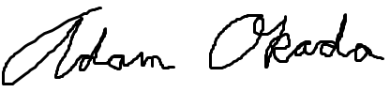
Adam Okada

